National College of Computer Studies
Paknajol, Kathmandu

Report on Penalty Shootout Game

Submitted by: Submitted to:
Ayush Tuladhar Yachu Shakya
BSc.CSIT 5th Sem
Section: A
Submission Date: 30th April 2026

Table of Contents
Abstract i
Introduction 1
Problem Statement 2
Objectives 3
Diagrams 4
Screenshot of the Application 6
Conclusion 10
Future Implementation 11

Abstract
The Penalty Shootout Game is a full-stack web application developed using PHP, JavaScript, HTML, CSS, and MySQL. The system simulates an interactive penalty shootout experience in which registered users take and save penalty kicks, answer football trivia questions as lifelines, and compete on a global leaderboard.
The application includes user authentication, game logic handled through JavaScript, backend processing with PHP APIs, and database storage using MySQL. It also features an admin panel for managing questions, scores, and system settings. The system provides both interactive gaming experience and a structured backend for managing users and data.
This report documents the motivation behind the project, its objectives, system architecture, implementation details, database design, and avenues for future development.

Introduction
The Penalty Shootout Game is a browser-based, full-stack web application that simulates the tension of a penalty shootout. Players aim and shoot at a goal while a goalkeeper AI attempts to dive and save the kick. When a player concedes a goal, they are offered a quiz lifeline — answering a football trivia question correctly allows them to stay in the game.
Unlike standalone or client-only games, every interaction is tied to a persistent backend. User accounts are protected by bcrypt-hashed passwords and PHP session management. Each completed game records detailed statistics — goals scored, goals saved, rounds played, and lifelines used — to a MySQL database. A leaderboard aggregates these records and ranks players by total goals scored.
The project also includes a fully functional administrative interface, accessible only to users with the admin role. Through this interface, an administrator can add, edit, and delete quiz questions; browse, edit, or delete individual game session records; and adjust the goalkeeper difficulty level from easy through to hard, with the change applying immediately to all new games.
The system is intentionally modular: the frontend communicates with the backend exclusively through three PHP API endpoints (auth, game, and admin), and all business logic is handled server-side. This makes the application a practical demonstration of full-stack web development with clear separation of concerns between presentation, logic, and data layers.

Problem Statement
Simple games are often built without structured data handling, user management, or persistence. This limits their functionality, as scores are not stored, users cannot track performance, and there is no centralized control over the system.
Additionally, many beginner-level projects do not integrate front-end interaction with backend systems, missing the opportunity to demonstrate full-stack development.
Therefore, there is a need for a system that provides interactive game experience, maintains user accounts and authentication, stores and displays scores and allows administrative control over the system.

Objectives
The main objective of the Penalty Shootout Game is to develop a full-stack web-based game with user interaction and data persistence.
Specific objectives include:
- Implement a secure user authentication system using bcrypt password hashing and PHP session management, supporting both regular user and admin roles.
- Develop an interactive, real-time penalty shootout engine in JavaScript, covering the kick phase (aim, power, shoot), the goalkeeper phase (save attempt with configurable AI accuracy), and animated result feedback.
- Integrate a quiz lifeline mechanic into the game flow, where conceding a goal triggers a multiple-choice football trivia question that can prevent elimination.
- Persist all game outcomes — including goals scored, goals saved, rounds played, and lifelines consumed — to a MySQL database using a RESTful PHP API.
- Display a live leaderboard that ranks all players by total goals scored, drawing from aggregated game session data.
- Build an administrative panel that enables quiz question management (add, edit, delete), game session management (view, edit, delete), and goalkeeper difficulty configuration (easy, medium, hard).
- Maintain clean separation between the frontend presentation layer, the backend API layer, and the database storage layer throughout the project.

Diagrams
Use Case Diagram
The use case diagram identifies two actors: the regular User and the Admin. Users can register an account, log in, play the game, and view the leaderboard. The Answer Quiz Lifeline use case is shown as an extension of Play Game — it is not independently accessible but triggered mid-game when a goal is conceded. Admins share only the Login and View Leaderboard use cases with regular users; they additionally manage quiz questions, manage game session records, and configure goalkeeper difficulty. Admins cannot self-register — the admin account is provisioned at the database level.
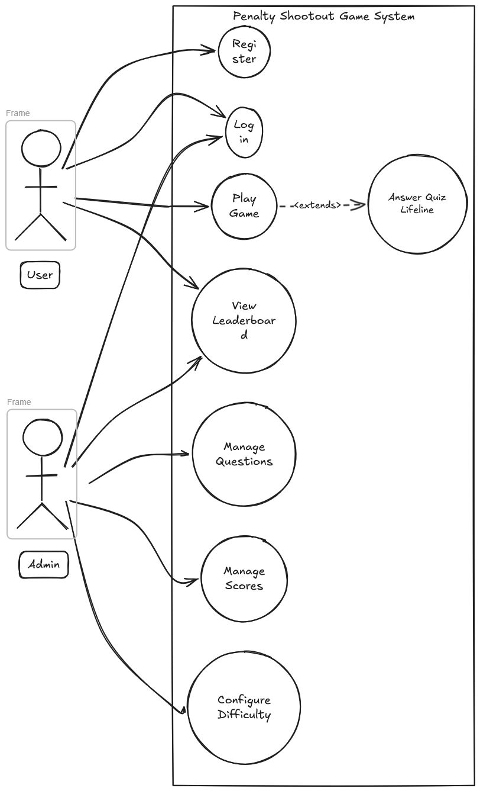
Figure 1: Use Case Diagram — Penalty Shootout Game
Entity-Relationship Diagram
The ER diagram models four entities. The USER entity stores account credentials and roles. The GAME_SESSION entity stores one record per completed game, linked to the user who played it; it captures goals scored, goals saved, rounds played, lifelines used, and a final score. The QUIZ_QUESTION entity stores all trivia content. The SETTINGS entity is a key-value store with no foreign key relationships, used to persist configuration such as goalkeeper difficulty.
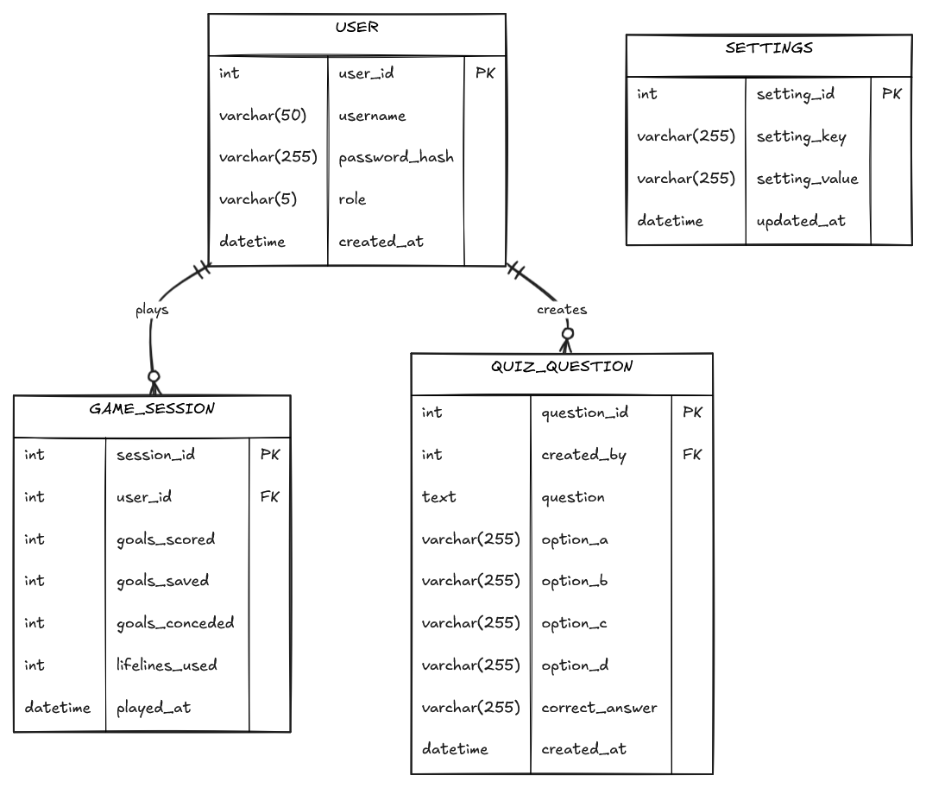
Figure 2: Entity-Relationship Diagram — Penalty Shootout Game

Screenshot of the Application
The following screenshots demonstrate the key interfaces of the Penalty Shootout Game, covering the user-facing game experience and the administrative management panel.
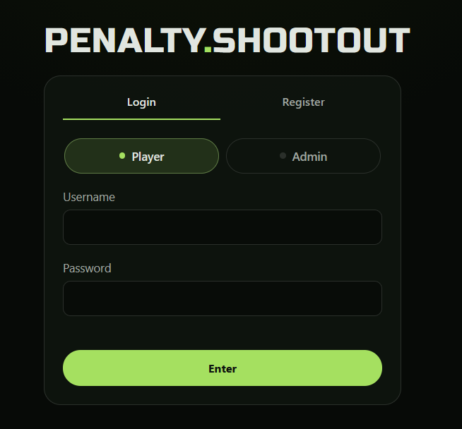
Figure 3: Login and Registration Page — Users authenticate or create a new account here. The form validates credentials against bcrypt-hashed passwords stored in the database.
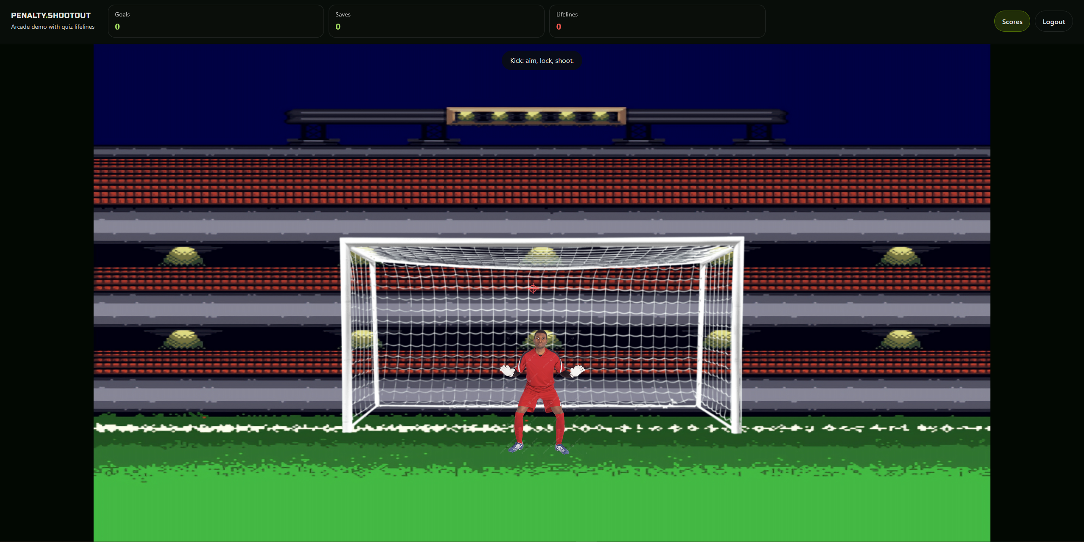
Figure 4: Main Game Interface — The penalty shootout arena showing the goal, goalkeeper, and the aim cursor during the kick phase. The HUD displays live goals, saves, rounds, and lifelines.
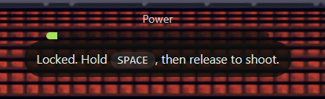
Figure 5: Power Bar — The power indicator that fills as the player holds the Space key. Releasing at the right moment determines shot speed.
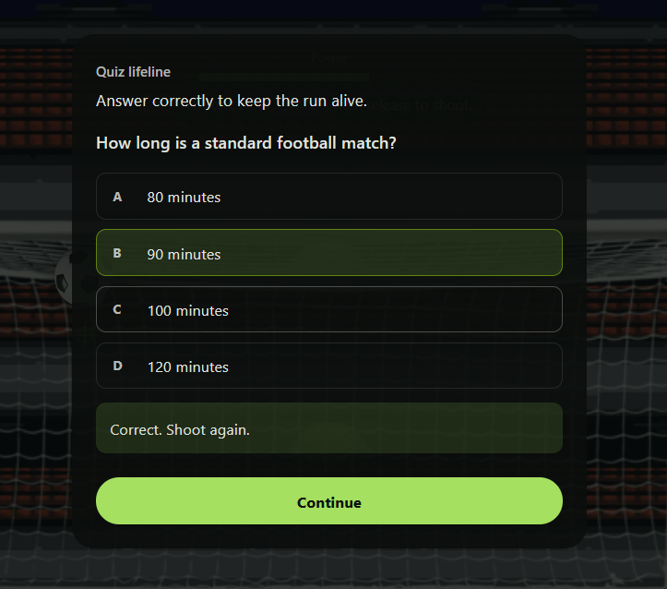
Figure 6: Quiz Lifeline Modal — When a player concedes a goal, a football trivia question appears. A correct answer reverses the conceded goal and allows play to continue.

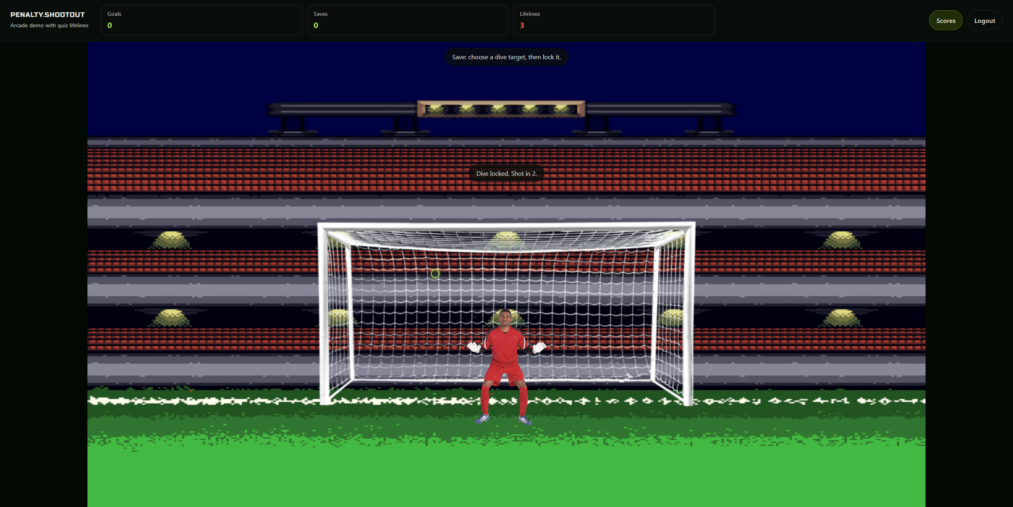
Figure 7: Goalkeeper Save Phase — The player must position their dive cursor to block the AI's shot. Goalkeeper’s accuracy varies by the difficulty configured in the admin settings.
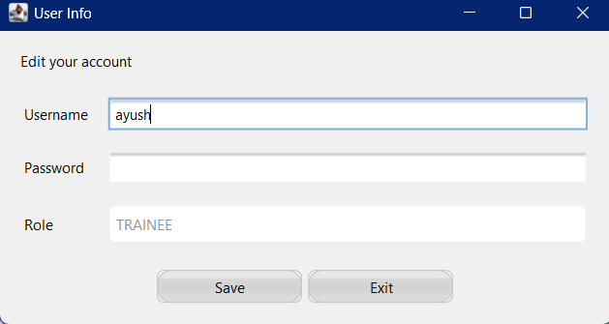
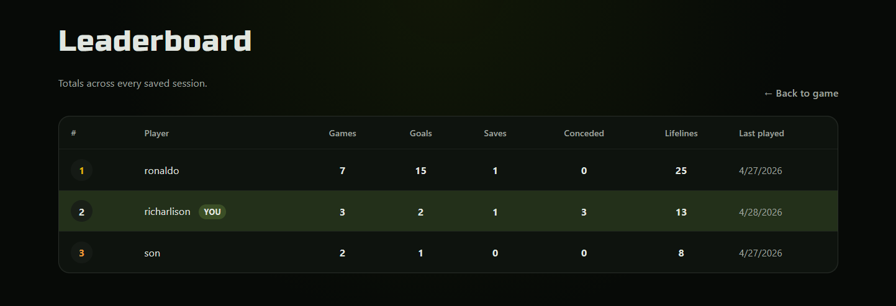
Figure 8: Leaderboard — All players ranked by total goals scored across all game sessions. The current user's row is highlighted for easy identification.
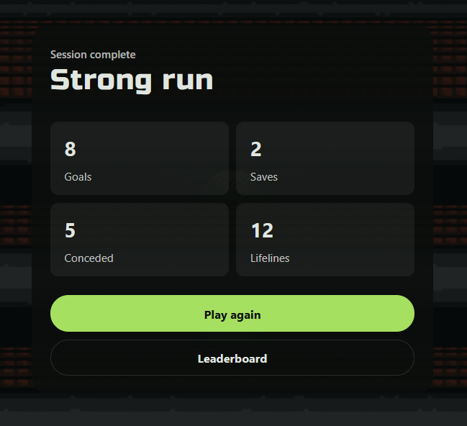
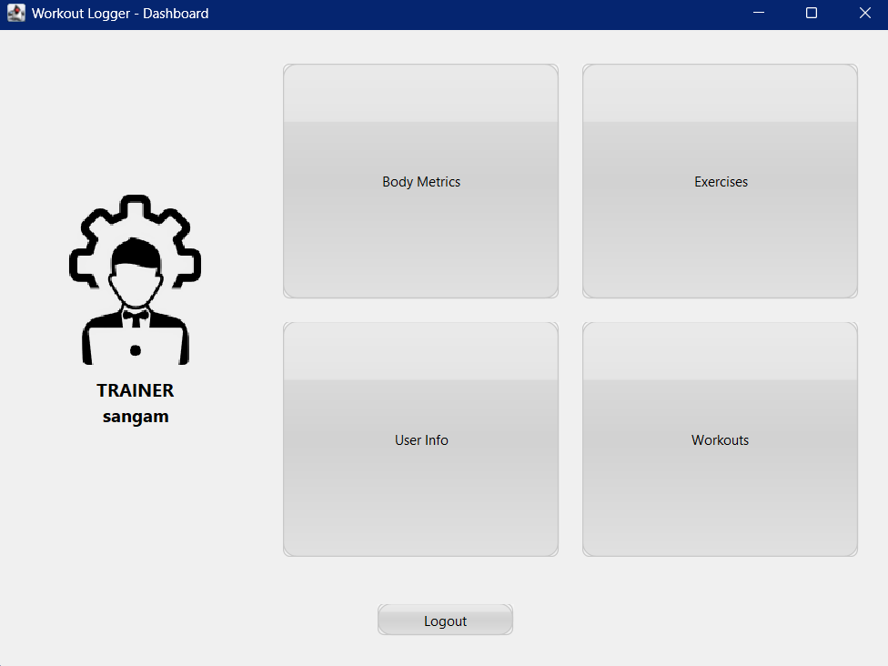
Figure 9: Game Over Screen — Summary displayed at the end of each game, showing goals scored, saves made, goals conceded, rounds played, and lifelines used.
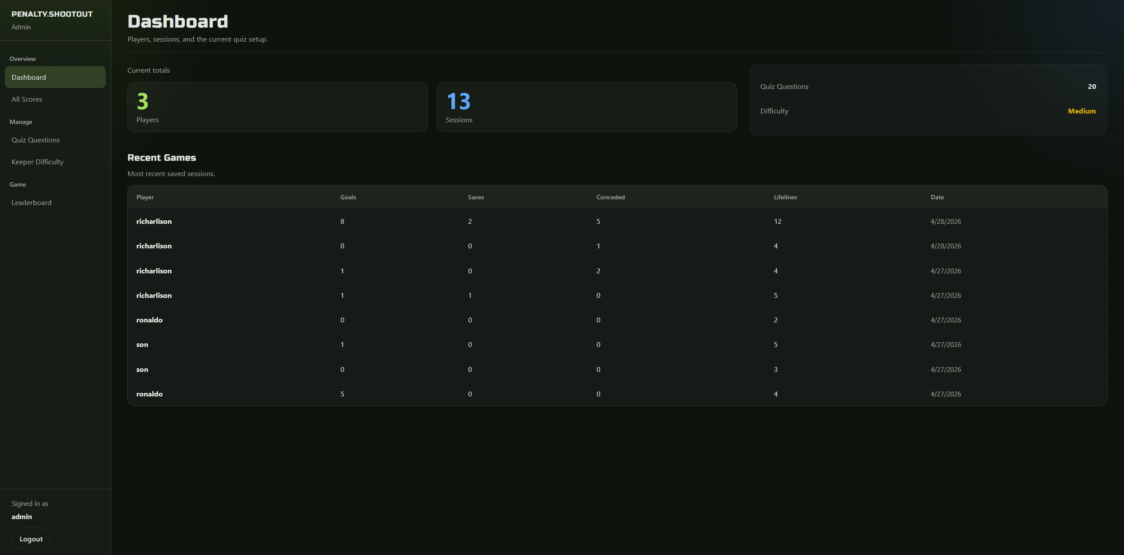
Figure 10: Admin Dashboard — System overview showing total players, total games played, total quiz questions, and the current goalkeeper difficulty setting.
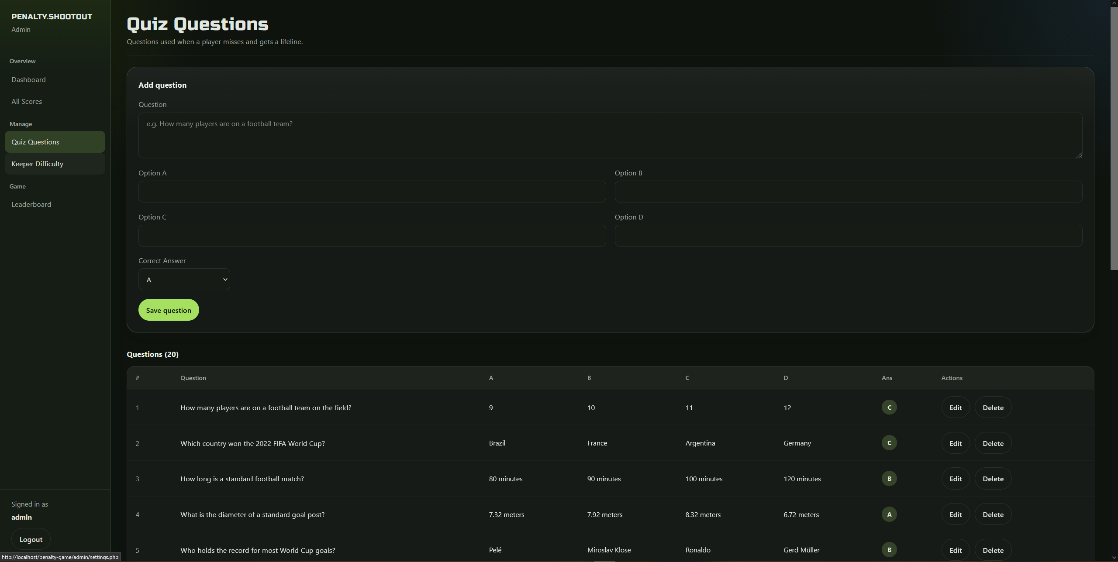
Figure 11: Admin Questions Manager — Administrators can add, edit, and delete football trivia questions. Each question includes four answer options and a designated correct answer.

Conclusion
The Penalty Shootout Game demonstrates a complete web-based application integrating frontend and backend technologies. It successfully combines user interaction, game logic, and persistent data storage.
The system goes beyond a simple game by including authentication, leaderboard tracking, and an administrative interface. This makes it a practical example of full-stack development using PHP and JavaScript.
Overall, the project is functional, modular, and structured in a way that supports future enhancements.

Future Implementation
Proposed future enhancements for the Penalty Shootout Game include:
- Enhancing game animations and realism
- Adding multiple difficulty levels
- Implementing multiplayer functionality
- Improving UI/UX design
- Adding session-based gameplay tracking
- Strengthening security (password hashing, validation improvements)
- Deploying the system online for real-world access

